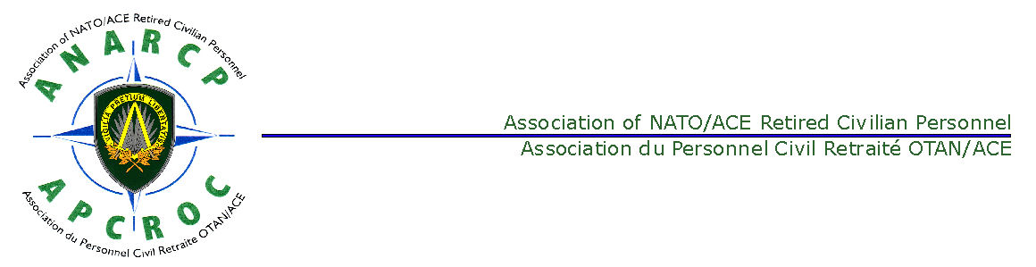

**Dated:** October 2013

**MINUTES OF A MEETING OF THE ANARCP PLENARY COMMITTEE HELD AT SHAPE ON 24 OCTOBER 2013**

**Present:**

Peter Ludford Chairman

Robert Moriau Vice Chairman

John Freeman Honorary President

Jean Delor Treasurer

Falko Bulling Member

Hessel Rutten Member

Jean Vanderwal BEL NatRep

Lis Jensen DNK NatRep

Rudiger Neitzel DEU NatRep

Graham Robertson FRA Dep NatRep

Jelle Batstra NLD NatRep

Jan Eiken NOR NatRep

Vincenzo Arzeni ITA NatRep

Atilla Aktuglu TUR NatRep

Doug Manocha GBR NatRep

Klaas van den Broek

Laurie Daykin Secretary

**Item 1 - Opening Remarks – Chairman**. The Chairman welcomed all to the Plenary Committee Meeting. He indicated that Mrs Monique Maggi and her husband would be attending the lunch. They would be presented with a thank you gift. He indicated that the meeting had a full agenda and that time should not be wasted on unproductive discussion.

**Item 2 – Review and Approval of the Agenda**. The agenda was approved.

**Agenda Item 3 – Approval of the Minutes of the Last Meeting**. NLD NatRep pointed out that the NLD report had not been included in the distribution. The Chairman said that he would redress this, which was probably due to a technical problem. The NLD report is at Annex I to these minutes. The minutes of the meeting of 15 May 2013 was approved. **Action: Secretary.**

**Item 4 – Staffing**.

1. **Bye Laws**. The Chairman gave an overview of the draft Bye-Laws and the redrafting process. He indicated that he appreciated the work done and comments made by all members of the Plenary Meeting, especially the Honorary President. Comments had been incorporated and the draft circulated on 28 September. After discussion and input from all members of the Plenary Meeting, further minor amendments, the Chairman asked for agreement to the Bye-Laws. The Bye-Laws were agreed. The Chairman indicated that the Secretary would provide members of the Plenary Meeting with the agreed and emended copy. The Chairman further pointed out that the Bye-Laws would be presented to the General Assembly for approval in May 2014. **Action. Chairman & Secretary.**
2. **Conduct and format of Committee Meetings**. The Chairman explained the reasons for not holding an Executive Meeting prior to the Plenary Meeting. After discussion, it was considered that there were practical reasons, including travel to be taken into account in deciding whether to hold an Executive Meeting. The Chairman indicated that in future, the agenda should dictate whether an Executive Meeting should be held prior to a Plenary Meeting.

**Item 5 – Financial Matters**. The Treasurer presented his report, which is at Annex A. The Treasurer pointed out that the 2 Euro increase to ANARCP membership fees would be payable at the end of 2013 for the dues for 2014. The Chairman indicated that he had received a communication which asked the following:

* Had the 2 euro increase been approved at the General Assembly?
* Had the budget for 2013 been approved?
* Was the Financial report approved by the General Assembly?

The Chairman responded ‘Yes’ to all three questions.

The Treasurer indicated that the accounts for 2010 to 2012 would be the subject of an Audit Report within one month. The Treasurer explained that the ANARCP banked with Fortis BNP Paribas and that ‘Withholding Tax’ applied to the account. The Mr Neitzel, the DEU NatRep, explained that he did not understand the membership process for ‘Autodeduction’ and that the membership process for new applicants was not clear to him. The Secretary indicated that he would provide all NatReps with a process for new members and that the new member application form would be redesigned to incorporate the form for ‘Autodeduction’ of fees. All agreed that this would make the system clearer. The revised process and form would be coordinated with the Treasurer and then provided to all NatReps. The Secretary indicated that he would contact the Pensions Unit in NATO HQ and periodically request a list of those NATO civilians who had recently retired. This would allow them to be approached directly. Mr. Bulling indicated that the Confederation of NATO Retired Civilian Staff Associations (CNRCSA) was undergoing a restructuring and that this must also be taken into account. It was agreed that it was unacceptable for NatReps to collect fees in cash and bank these into the ANARCP account. NatReps asked for details of the ANARCP international account details to be included in the minutes.

ANARCP Account:

IBAN : BE57 2700 4624 7835 BIC : GEBABEBB

A.N.A.R.C.P. - A.P.C.R.O.C.

The Treasurer indicated that he would write to all NatReps listing which members receive a pension and therefore should be Autodecuted. **Action: Secretary & Treasurer.**

**Item 6 - Registered Partners of Retirees Entitled to a Survivors Pension**. Mr. Batstra outlined the situation regarding registered partners in the Netherlands. After discussion it appeared that registered partners are not recognized for pension [succession](ww:succession) purposes in neither the Netherlands nor The United States. Neither the Pension Scheme Regulations nor the NATO Group Insurance Contract recognize registered partners per se. However, it seems that AWC is prepared to recognise registered partners if supported by official documents. Attention is also drawn to the Preamble of the NATO Civilian Personnel Regulation which recognizes registered partnership under B (h)ii. This issue will be addressed at the CNRCSA at the 21 Nov 13 meeting. **Action: Mr. Bulling and Mr. Moriau.**

**Afternote by Mr. Jelle Batstra:** In The Netherlands, if two persons have a registered partnership, a registered survivor would normally be entitled for a survivor pension.

**Item 7 - Interface between and the Relative responsibilities of the CNRCSA and ANARCP**. Mr. Moriau, the Chairman of the CNRCSA, indicated that he would be inviting NatReps to come together with other national Reps from other retiree organisations for an exchange of information and ideas. He indicated that some organisations did not have the ANARCP’s level of representation. He indicated that aim is to have all of the NatReps from all of the organisations to make an agreement on who would be the regional representative to the CNRCSA. On conclusion of the agreement, there would be an annual meeting for the designated regional representatives. After discussion, it was considered that this arrangement was unlikely to succeed. The Chairman indicated that although some issues were similar across the organisations, some were quite different. The Chairman indicated that he would present the ANARCP system of NatReps to the CNRCSA on 21 Nov 13. **Action: Chairman.**

**Item 8 – AWC Matters Including Insurance Cards.** Mr. Bulling briefed the meeting on aspects of the AWC.

1. **Transportation costs for out-patients visiting the nearest Medical Consultant**. Mr. Bulling indicated that despite exhaustive discussion, AWC and NATO have decided that transport costs for outpatients visiting a consultant will not be met by AWC as not being covered by the NGIC. The CNRCSA WG can understand this decision but will be address this issue at the next CNRCSA EXCOM meeting for decision.
2. **Transportation costs to and from a convalescent home/rehabilitation facility from hospital**. Under the Van Breda contract this cost would be met after prior approval. However, AWC will not meet this cost. However, in Ambassador Eaton’s letter, dated 28 Nov 11, it was confirmed that there would be no changes to the benefits and services provided by van Breda. AWC’s response was that Van Breda had paid this cost in error. Mr. Bulling indicated that this response from AWC was unacceptable for the CNRCSA WG. This issue will be discussed at the CNRCSA EXCOM on 21 Nov 13. Mr. Bulling indicated that the aim is sending a letter to the Assistant Secretary General asking for reconsideration of the issue.
3. **Primary Insurance**. Mr. Bulling outlined the system with regard to primary medical insurance. He indicated that where there is another system of health care indemnity, for example, a national system, this should take primacy. Mr. Neitzel indicated that how this was interpreted was important because it would determine how much could be reimbursed overall. A question arose with regard to travel insurance and whether this should be considered the ‘primary medical insurance’. Mr. Bulling indicated that he would look into the matter. **Action: Mr Bulling.**
4. **Claim-handling via postal service**. Mr. Bulling indicated that although there has been a problem with handling of claims sent by post, AWC had underestimated the number of beneficiaries without access to the World Wide Web and had subsequently increased the number of personnel handling postal claims tenfold.
5. **Claim-handling in case of serious illness**. In case of serious illness, AWC have refused to reimburse any of the costs until the medical services have agreed that the case is a serious illness. Claimants would prefer bills to be paid by 90% immediately on presentation and the remaining 10% at a later date.. Unfortunately, AWC does not have medical histories taken over from Van Breda; this therefore makes their task difficult and may prolong the time of decision.
6. **NATO owned Database not complete**. Mr Bulling explained that Confederation, in cross-checking the data on the NATO database had revealed that a number of personnel for whom AWC provide medical insurance are not on their database. ARO has asked NATO to discuss this possible mismatch in July 2013 but no reaction as of today.
7. **Future of NGIC, safeguard of benefits, RMCF**. The NGIC is annually renewed by tacit agreement. The notification to terminate the contract must be made six months prior to termination at the end of the year. There is clear indication by NATO and the Confederation of NATO Civilian Staff Committees representing the active staff that modifications are required to the benefits of the NGIC and the way how the retired staff is financing its part of the RMCF. The CNCSC and the CNRCSA have not reached agreement on how to tackle this problem.
8. **Revision of NATO Benefit Guide**. There was no news on the revised AWC booklet. Revisions had been proposed but no response has been received. It is understood that this uncoordinated document is ready for printing. Note e-mail from Mr. Bulling dated 25/10/2013 on this issue.

Mr Bulling answered questions on the following:

a. **Home Care**. AWC does not cover non-medical care which is performed at home by nurses or family members but will cover residence in a nursing home. However, the costs for (limited) medical supervision by a nurse at home based upon prior approval are reimbursable. The need for a care taker, particularly for members with dementia is becoming more prevalent. This issue will be addressed to the Executive Committee of the CNRCSA on 21 Nov 13.

b. **MRI Scans**. MRI Scans can be expensive. Preventive scans are not covered by AWC. However, they are covered when a doctor confirms that it is required.

c. **Payment in Advance**. Mr Bulling explained that it is possible to seek reimbursement of an invoice prior to its payment by the beneficiary.

d. **AWC Cards in Turkish**. Mr. Atilla Aktuglu, the TUR NatRep, asked about obtaining AWC cards for his members in Turkish with the correct telephone numbers thereon. This was requested two years ago. Mr. Bulling did not have additional information but agreed to re-discuss this issue with AWC. **Action Mr Bulling.**

 a. Home Care. AWC does not cover non-medical care which is performed at home by nurses or family members but will cover residence in a nursing home. However, the costs for (limited) medical supervision by a nurse at home based upon prior approval are reimbursable. The need for a care taker, particularly for members with dementia is becoming more prevalent. This issue will be addressed to the Executive Committee of the CNRCSA on 21 Nov 13.

**Afternote**: Mr. Bulling has provided the additional information at Annex C.

**Agenda Item 9 – Updates**

1. **Chairman**. The Chairman indicated that he had appointed Mr. Jean Vanderwal as the NatRep for BEL and welcomed him to this, his first, meeting. He thanked Mr Vanderwal for establishing contact with the SHAPE CSA and allowing him to attend its monthly committee meetings as an observer.
2. **NATREPs**:
3. **DEU NATRep**. Mr. Neitzel stated that he wished to have Mr. Chalmers, who is based in the Geilenkirchen area, as his Deputy. The Chairman explained that it was not possible to have two Deputies for a single Nat Rep and that he had received Mr Neitzel’s E mail and that he had not replied pending this meeting. After discussion, the Chairman stated that he would contact Mr. Dittmar the current Deputy NatRep, who lives in the Augsburg area of Germany. He would explain to Mr. Dittmar the advantageous of having a deputy in the Geilenkirchen area. If Mr. Dittmar agreed to demit from the post as Deputy NatRep then he would, on the recommendation of Mr Neitzel, appoint Mr Chalmers as the DEU Deputy NatRep. Mr Neitzel announced that Child Allowance would no longer be taxed in Germany and that members may claim a reimbursement.
4. **GBR NATRep**. Mr. Manocha indicated that an ANARCP member, who is a UK national, was based in Germany and moved to Spain, had asked for legal expenses related to a German legal tax case to be paid for from ANARCP funds. Mrs. Sutherland regretted that the UK Representative had not supported the request to ANARCP to subsidize the  cost for the German test case on the taxation of the NATO “Pension” pending at the financial court in Munich, although the outcome would apply to all 300 retirees in Germany. In order to be kept abreast she had asked to be transferred to the German National Representative, who agreed to include her in his mail distribution. The meeting was, however, reminded that the ANARCP Executive Committee and NatReps, are not tax advisors.
5. **NOR NATRep**. Mr Eiken indicated that there are currently 46 members. One member had died. He stated that he would continue to provide Norwegian members based in Belgium information of interest to them.
6. **FRA NATRep**. There will be a social gathering next year.
7. **NLD NATRep**. There were ongoing taxation issues which are in hand.
8. **TUR NATRep**. The TUR Nat Rep’s report is at Annex D.
9. **ITA NATRep**. The ITA Nat Rep’s report is at Annex E.
10. **BEL NATRep**. The BEL NatRep indicated that he is working with the Vice Chairman to look into salary adjustments. He is working closely with the Secretary on the SHAPE Entry cards for BEL members for 2014.
11. **Chairman of the Confederation of NATO Retired Staff Association -** Mr Moriau The Chairman of the CNRCSA, Mr Moriau, briefed the meeting on various subjects. His speaking notes are at Annex F. Mr Moriau explained that salaries and therefore pension adjustments recommended by the CCR (Coordinated Committee on Remuneration) are subject to agreement by the various councils. In the past NATO had applied negative adjustments and is likely to do so in the future. The CCR recommendations for 2014 are detailed at Annex G. Mr Bulling indicated that active staff members could appeal against the non implementation of salary adjustments.
12. Mr Bulling indicated that the Chairman of the CNRCSA had written to SACEUR in May 2013 regarding the provision of support for NatReps. This letter had taken a circuitous route via the ANARCP’s patron and had eventually reached the Command Group in October 2013. An answer was expected soon and the support provided to the ANARCP would also be included in ACO Dir 50-1 to be promulgated in the spring of 2014.
13. **Secretary**. The Secretary briefed on Secretarial activities post assumption of duties. This notes are at Annex H. He indicated that he believed that ANARCP membership cards fulfilled no function that he could identify and that the ANARCP should give consideration to discontinue issuing them. He suggested that an email or letter confirming the membership should suffice.This will be addressed at the meeting in May 2014. **Action: Secretary.**

**Agenda Item 10 – Administrative Matters - Website**. There was discussion on the ANARCP website. The Chairman agreed to coordinate with Mr Batstra and Mr van den Broek to update the ANARCP website. A number of documents were proposed for inclusion in the site.

**Agenda Item 11 – AOB**. There was no other business

**Agenda Item 12 – Date and Place of Next Meeting**. The next Plenary meeting will take place on 22 May 2014. The General Assembly will take place on 23 May 2014.

**Agenda Item 13 – Closing Remarks**. The Chairman thanked the Honorary President who had done an excellent job of arranging the venue and the lunch. The Chairman thanked all for attending and wished them a safe journey home.

Peter Ludford

Chairman

Annexes:

1. Financial Statement 2013
2. Draft Budget 2014
3. Additional Information Provided by Mr. Bulling
4. TUR Nat Rep’s Report
5. ITA Nat Rep’s Report
6. Chairman of the Confederation of NATO Retired Staff Association – Speaking Notes
7. Salary Adjustment
8. Secretary’s Report
9. The NLD NatRep Report of 15 May 2013

**Annex A**

|  |  |  |  |  |  |  |
| --- | --- | --- | --- | --- | --- | --- |
| **ANARCP FINANCIAL STATEMENT PER 30.09.2013 in euro** | | | | | | |
| (From 01.01.13 until 30.09.13) | | |  |  |  |  |
|  |  |  |  |  |  |  |
|  |  |  |  |  |  |  |
| ***EXPENDITURES*** | |  |  |  |  |  |
|  |  |  |  |  |  |  |
|  |  |  |  |  |  |  |
| POSTAGE | | |  | 82.78 |  |  |
| STATIONARY | | |  | 866.60 |  |  |
| BANK CHARGES | | |  | 23.40 |  |  |
| HOSPITALITY | | |  | 0.00 |  |  |
| WEBSITE | | |  | 38.72 |  |  |
| TEL NATREP | | |  | 9.83 |  |  |
| TRAVEL | | |  | 2,849.18 |  |  |
| LOCAL ACTIVITIES ( NatRep) | | |  | 802.00 |  |  |
| GENERAL ASSEMBLY + Exec Cottee | | |  | 1,546.05 |  |  |
|  |  |  |  |  | 6,218.56 |  |
| ***INCOME*** | |  |  |  |  |  |
|  |  |  |  |  |  |  |
|  |  |  |  |  |  |  |
| FEES MEMBERSHIP | | |  | 8,912.62 |  |  |
| TRAVEL | | |  | 943.75 |  |  |
| INTEREST EARNED (6 + 2036,47 Saving) | | |  | 2,042.47 |  |  |
|  |  |  |  |  | 11,898.84 |  |
| **RECONCILIATION ASSETS/ACCOUNTING** | | | |  |  |  |
|  |  |  |  |  |  |  |
| BANK per 01.01.13 | |  |  | 5,116.84 |  |  |
| SAVINGS per 01.01.13 | |  |  | 97,144.34 |  |  |
|  | |  |  |  | 102,261.18 |  |
|  |  |  |  |  |  |  |
| INCOME | |  |  |  | 11898.84 |  |
| EXPENDITURES | |  |  |  | 6218.56 |  |
|  |  |  |  |  |  | 107,941.46 |
| BANK per 30.09.2013 | |  |  | 8,760.65 |  |  |
| SAVINGS per 30.09.2013 | |  |  | 99,180.81 |  |  |
|  |  |  |  |  |  | 107,941.46 |
| DIFFERENCE | |  |  |  |  | 0.00 |
| J.E.D. |  |  |  |  |  |  |
| 10/10/2013 |  |  |  |  |  |  |

**Annex B**

|  |  |  |  |  |  |  |
| --- | --- | --- | --- | --- | --- | --- |
| **ANARCP DRAFT BUDGET 2014 in euro** | | | | | | |
| **EXPENDITURES** | |  |  |  | As of 31/12/2012 | |
| POSTAGE | |  | 450.00 |  | 296 |  |
| STATIONARY | |  | 1,850.00 |  | 1072 |  |
| AGA/DINNER | |  | 3,970.00 |  | 3378 |  |
| TRAVEL | |  | 3,500.00 |  | 3548 |  |
| BANK CHARGES | |  | 30.00 |  | 31 |  |
| NATREP ACTIVITIES (5€ per member) | | | 4,700.00 |  | 1368 |  |
| HOSPITALITY | |  | 150.00 |  | 54 |  |
| WEB SITE |  |  | 150.00 |  | 148 |  |
| TEL. NATREP | |  | 25.00 |  | 10 |  |
| Contribution to Confed. (2€ per member) | | | 2,200.00 |  |  |  |
|  |  |  |  | **17,025.00** |  | 9905 |
| **INCOME** |  |  |  |  |  |  |
|  |  |  |  |  |  |  |
| FEES (800 x 15) | |  | 12,000.00 |  | 9524 |  |
| AGA/DINNER | |  | 1,575.00 |  | 1645 |  |
| TRAVEL |  |  | 2,200.00 |  | 2210 |  |
| INTEREST EARNED | |  | 1,250.00 |  | 1891 |  |
|  |  |  |  | **17,025.00** |  | 15270 |
| **PROJECTED CHANGE OF NET WORTH** | | | |  |  |  |
| Bank per 1 October 2013 | |  | 8,760.65 |  |  |  |
| Savings per 1 October 2013 | |  | 99,180.81 |  |  |  |
|  | |  |  |  |  |  |
|  |  |  |  | **107,941.46** |  |  |
| Income |  |  |  | 17025 |  | 15270 |
| Expenditures |  |  |  | 17025 |  | 9905 |
|  |  |  |  | **107,941.46** |  | 5,365.00 |
| Yearly contribution increased to 15 Euros. | | | | | | |
| Exchange rate October 2013 | | |  |  |  |  |
| 1euro = | 0,848 £ | 15 euros = | 13 £ |  |  |  |
|  | 1,35 US$ |  | 20 US$ |  |  |  |
|  | 1,404 CA $ |  | 21 CA$ |  |  |  |
|  | 7,456 DKK |  | 112 DKK |  |  |  |
|  | 8,174 NOK |  | 123 NOK |  |  |  |
|  | 2,672 TL |  | 40 TL |  |  |  |
| JED 10/10/2013 | |  |  |  |  |  |

**Annex C**

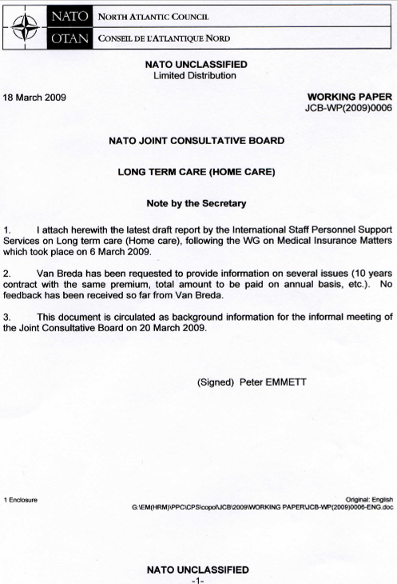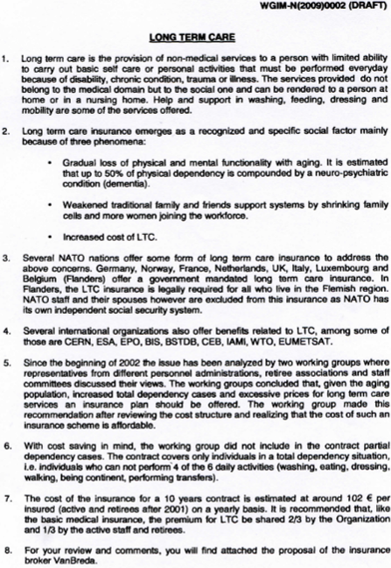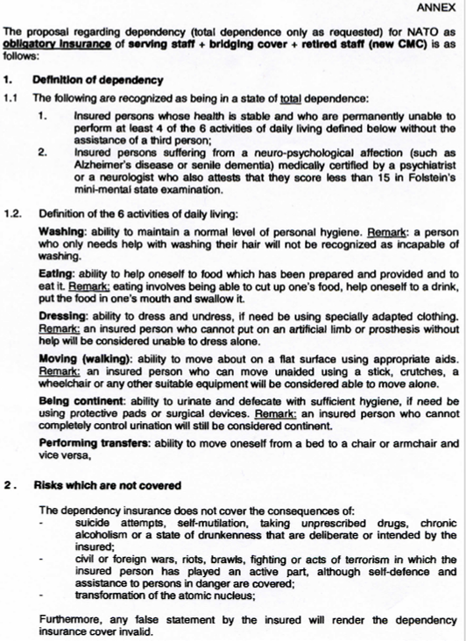

**Annex D**

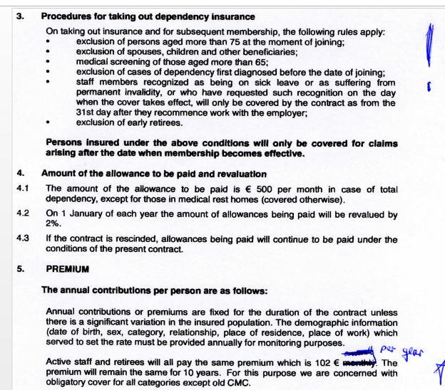

**NATREP TURKEY - PLENARY MEETING, 24 OCTOBER 2013**

1. Good afternoon! First of all, I would like to thank you Mr. Chairman for your kind consideration to change the date of the plenary to accommodate those of us who had previous commitments on the initial date of the meeting.
2. Regarding Mr. Moriau’s request to determine one NatRep for each retiree association to attend confederation meetings, our query to learn the number of ARO retirees residing in Turkey resulted in only 12; therefore with 63 ANARCP members (after the recent decease of Mr. Tayyar Unluer) i propose my Deputy as NatRep and myself as deputy NatRep for this tasking.
3. Our plans to pay courtesy visits to our new command group could not be realised up to this date mainly because of the volatile situation which prevailed last summer. We are waiting to hear from the secretaries of the commanders for a timely visit.
4. We held two social events with 39 participants in February and 21 participants in July.
5. As regards salaries, a working group was formed to study and try to find out the reason for the loss of purchasing power of NATO civilian salaries in Turkey resulting from salary adjustments falling behind actual changes in cost of living. The study and the findings of the W.G. were briefed by the Chairperson of HQ land command, Izmir to participants of the confederation meeting, which was held last week.
6. Last but not the least; since 2012 which marks the beginning of NATO’s change of health insurance from CIGNA (Van Breda) to Allianz, we have been trying to get our insurance cards re-printed to show the correct toll free telephone number for Allianz. i have forgotten the number of times we reminded the said insurance company reps to implement this correction; all we got was a nice smile and promises. **How can we stress more the importance of this change** as the lack of it causes **serious hardship** for our elderly retirees and/or their non-English/French speaking next of kin in their dealings with the local hospitals?

**Annex E**

**ITALY NAT REP NOTES**

Good Afternoon, my name is Vincenzo Arzeni and since July this year I represent the NATO Retirees in Italy. I substitute Mr. Ernesto Mosca who resigned from his office due to a principle that we, in Italy, will apply in the future as well. That is, we believe that a NAT REP should not remain in his office for more than five years. A new Nat Rep may have more enthusiasm and new ideas as well.

The new deputy is Mr. Francesco Veltri.

Due to the relocation of JFC Naples from Bagnoli to Lago Patria, connected poorly with Naples, it is very difficult to meet with the other colleagues and share comments or ideas with them. The electronic mail helps.

The JFC Naples staff elected a new CSA Chairman, Mr Josuè De Gennaro, and we hope that a more fruitful cooperation will be set up with him.

Due to the relocation of the HQ, we requested to the Command Group a room like the ones we had in Bagnoli. In spite of the meeting with the CG Commander since November 2012, until today we have not yet been able to obtain a space where to meet. An official request, through the NATO Civilian Officer, Dr. Tony Quattrone, has been put forward and we are waiting for an answer.

In relation to the cases pertaining to the taxation of pensions, many of us had a positive answer from either Provincial or Regional Court, but the Tax Agency always appeals to the Supreme Court and we are waiting, since three years that the case related to Mr. Carpi is examined.

Regarding the AWC, we are having difficulties with the new attitude of AWC requiring evidence of the payments we make to the doctors ( check, bank transfer). If this has been an agreement between NATO and AWC, I would like to have the document and, if possible, the Insurance Policy that NATO signed with Allianz.

We are looking forward to organizing a Christmas party somewhere in Naples.

**Annex F**

**SPEAKING NOTES CHAIRMAN CNRCSA**

- MESSAGE NOT VERY OPTIMISTIC

- LOT OF THINGS ARE MOVING IN THE WRONG DIRECTION

o- **REFORM OF APPEAL BOARD**- ADMINISTRATIVE TRIBUNAL

SERIOUS SHORTCOMINGS FOR RETIREES /EXTERNAL COURTS ?

o-**TAX ADJUSTMENT** DCPS :2-6 ; WHAT AND WHERE NEXT?

REACTIONS : ADMIN- LEGAL

OUR LTR TO DSG / BACKGROUND

o**- HEALTH INSURANCE** :

RMCF 65/25- NO PREMIUM FOR RETIREES / BRIDGERS PAY

LT FINANCIAL SURVIVAL

ACTIVE STAFF SHOWS A WRONG PICTURE

TENTATIVES TO COOPERATE WITH ACTIVE STAFF REP

DECREASE IN NR ACTIVE STAFF/ INCREASE IN NR RETIREES

RESPONSIBILITY OF NATO : REORGANISATIONS…

AWC :CLAIMS FIRST TO NAT. HEALTH SYSTEM ( - 70 TO 90 %)

o- **AFFORDABILITY CLAUSE** : ENDANGERS SALARY/ PENSION ADJUST PROCEDURE.. /PERMANENT UNREST..

o- **JCB** NO MEETINGS BUT COMMENTS ON DOCUMENTS /ACTIVE STAFF ( DSG/ NATIONS)

o- **GENERAL DISCONTENT** : DEMONSTRATIONS ACTIVE+RETIREES :

OECD 28.11.12/ NATO 03.12.12

o- **LACK OF INFORMATION** : INFORMATION DOES NOT REACH ALL RETIREES FORMALLY/OFFICIALLY.

o- LASTLY A WORD ON THE ONGOING **REORGANISATION** OF OUR CONF.

TO STREAMLINE/STRENGTHEN – CLOSE TO THE DECISION MAKING FORA.

BUDGET/CONTRIBUTIONS

RGIONAL REPS/ DIALOGUE- EXCHANGE OF IDEAS

STANDARD MEMBERSHIP CARDS.

**CONCLUSION**

o- NATO REDUCES SYSTEMATICALLY OUR BENEFITS

PENSIONS AND HEALTHCARE

WE WILL CONTINUE TO DEFEND AND FIGHT

o- NO TRUST NOR COOPERATION BETWEEN ADMIN/ACTIVE/RETIREES

WE WILL TRY TO RESTORE

o- DISTURBING ROLE OF NATIONS

IGNORE SOCIAL ACTORS/NO DIALOGUE

MICROMANAGEMENT

THANK YOU/ ANY QUESTIONS??

RJM 22.10.13

**Annex GAnnex H**

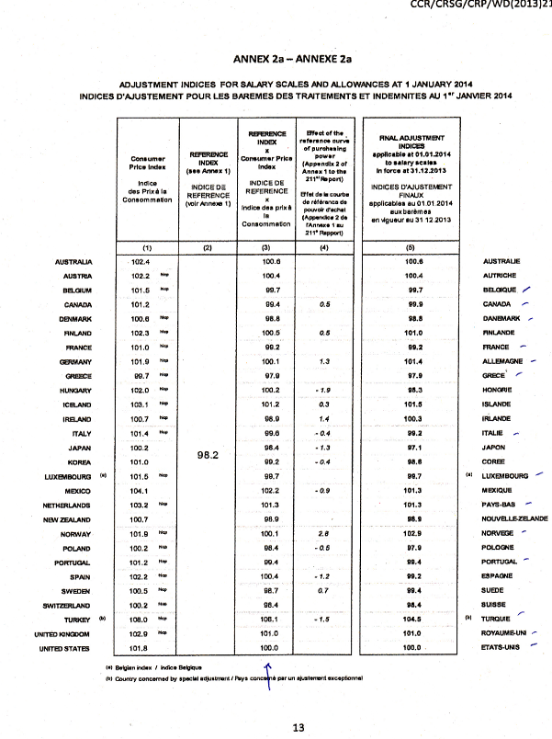

**Secretary’s Report 24 Oct 13**

**Mr. Chairman, ladies and Gentlemen, Good Morning/Afternoon.**

Laurie Daykin, the ANACP Secretary. This is my first report to the ANARCP, so I apologise if it’s not quite what you were expecting.

**General**

Assumed Secretarial responsibilities on 13 August as per the Bye-Laws of 4 May 2006.

**Members**

Currently there are 1088 members or surviving spouses give or take 5. Although we are still reconciling the databases. Since assuming responsibilities 6 members have died. Unfortunately, we’re often not told when members die, so we sometimes have to backtrack to find them. There have been 20 new members Since 15 May 13. One member resigned. Extrapolating that figure for the whole year it means that we will have approximately 50 new members per year. The current Bye-laws of May 2006 allow those with more than 15 years membership to forgo payment. For 2014 that will involve 48 members.

**Database Reconciliation**

At the end of September, NATREPs were provided with Secretarial copies of their databases and received most of them by 7 October. Since then the 7 national databases and the global database have been brought into line. Only one nation to be completed. The Secretary would like to thank the NATREPs for their work and patience in checking the data and cooperating on this work.

**Practical Matters**

After three years inoperative, there is a working computer in the ANARCP room. Printer is expected to be working shortly.

**Membership Cards**

The utility of membership card is questioned.

**Office**

As per Section 1 of the Constitution dated 17 February 2003, we have an office in SHAPE. That office is 204c is available for Executive members to use.

**Access 2014**

For Belgium members, in coordination with Jean Vanderwal, the Belgium NATREP, 100, 2014 Entry Cards will be applied for. Green, vehicle access cards will also be requested for Executive Committee members.

**Annex I**

**Report of the National Representative for The Netherlands**

**2012-2013**

ANARCP-NL currently has 299 members that retired from military headquarters. We also are the contact point for 22 retirees from ARO.

Contact with NATO IS-PSS

Many staff were shocked to receive a letter from NATO-IS via ALLIANZ WorldwideCare, announcing premium increases. This letter was sent to a large group for which it was not intended, and moreover, we feel that the retirees that were affected should be informed by NATO and not by AWC.

It shows that the competence of the NATO Office is doubtful.

Transfer from Vanbreda to Allianz Worldwide Care.

The whole transfer process during 2012 has had a disastrous start and a vulnerable group of NATO retirees had initially been served very badly, both by NATO IS and AWC. We still feel that NATO IS to be blamed for this and that the Sec Gen is insufficiently aware of the problems that this has caused.

However, during the latter half of 2012 and the first months of 2013, the process of claim handling has been running smoothly.

Some questions that I received, mainly on hospitalization, and rest homes, were sorted out in a dialogue with AWC.

On a number of occasions we asked AWC to directly contact hospitals and health institutions to sort out direct billing problems.

We feel that in the case of Direct Billing, automatically copies of bills should be sent to retirees concerned. Improper billing can have an effect our premium.

Taxation on NATO pensions

During 2010, the Coordinated Retiree Organizations in The Netherlands (NATO and ESA) have, with support of AAPOCAD, hired an expert to discuss the issue of taxation of coordinated pensions with the Dutch Ministry of Finance, with respect to a verdict by the Dutch High Court, on taxation of the pensions of retirees from the United Nations.

Discussions with the Ministry of Finance initially seemed to move in a favorable direction, but unfortunately, an ex EPO employee launched a Court Case on similar issues, unfortunately using irrelevant arguments. The Ministry of Finance stopped the discussions with our spokesman, awaiting the outcome of this court case.

The Court ruled negative and the EPO retiree was planning to appeal against the Courts decision. However, the appellant ran out of funding, did not appeal but started a discussion with the tax office.

The EPO retirees seem to have reached a compromise with the tax office, were they will have a one time choice between a tax free pension for 2 to 2 ½ years and normal taxation thereafter, or construction where 1/3 of the pension is taxed as an asset and the rest as normal income.

This compromise seems attractive, but it complete neglects legislation in the Dutch Income Taxation with respect to double taxation.

This elements was insufficiently addressed in the EPO court Case and the pensioners of the coordinated Organizations’ in The Netherlands (NATO and ESA) have contacted a lawyer, who has been involved in the U.N. Tax case in 2009 in the Dutch High Court, and who considers that a new court case, using the right arguments, has a good chance of success.

Financial support has been granted by AAPOCAD, ARO, ARES. We have asked ANARCP to also provide financial support.

Annual General Meeting in The Netherlands.

An Annual General meeting was organized on 22 March on the NCIA premises in The Hague to bring pensioners up to date. The Meeting was well attended by some 90 persons, and the items mentioned above were discussed in detail.

Due to new regulations in the Tax Office, help for completing the Income Tax assessment could not be provided by the officials of the Tax Office.

During this meeting AWC gave a presentation and was available for a question and answer session.

The meeting was followed by a social event, a luncheon in the NC3A Staff Restaurant, which was attended by 67 persons.

Contact with Associations of active staff

IOSA Meetings with IOSA (International Organizations’ Staff Associations) were attended. Issues discussed here (Requirements for International Schools, medical care, problems in terminating the existence of an International Organization (ICTY), finding a house etc.) are mostly relevant to active staff.

Unfortunately, retirees from the other International Organizations did not attend these meetings.

We frequently have contact with both the NCIA Staff Association and NCIA administration.

There are plans to contact JFC and NAPMA Active staff.

Distribution of information

We have extensively used the option of distribution of information by e-mail. Especially, when on short notice information had to be distributed, this worked excellently. We will continue to use these possibilities.

NCI Agency management has indicated that they plan to continue the support to ANARCP-NL.

Jelle Batstra

14 May 2012